Friday Afternoon Movie
@ the Library

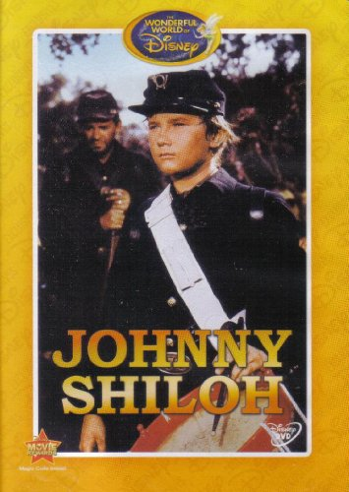
Johnny
Shiloh

Friday, November 3
1:45 p.m.

The Walt Disney, made for TV movie “Johnny Shiloh” is the true story about Johnny Clem, the ten year old drummer boy who became a union officer in the Civil War.

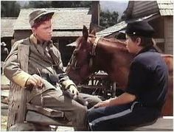
Bring your own drink, the library provides the popcorn!

